Project 1 Programmer Manual
Steve Walinski
CS221 – October 20th, 2014

1. Problem Description

The program will prompt the user for an input of ten integers. Once the integers are read in, the program will places the integers into two arrays, where it will keep a copy of one array as an unsorted list. From there, the program will use the insertion sort algortihm to sort the elements of the second array from least to greatest. Lastly, the program will create a table, in which it will hold both the unsorted and the sorted lists, and a proper heading to identify between the two.

2. Data Types

2.1 dw:

tabl1 – array that holds the values of the unsorted list

tabl2 – array that holds the values of the sorted lisr

flrcnt – represents how many blocks needed to make a “floor” for the table

count – represents the maximum input

temp – array that holds values passed in by reference, gets sorted, and passes back by
modifying the stack.

counter – represents maximum input as well

2.2 db:

Prompt – holds message asking user for input

name1 – holds name of table 1

name2 – holds name of table 2

spacer – used to space out and align table

Msgg1 – prints out name of program

Msgg2 – prints out name of programmer

Msgg3 – prints out date

blankline – used to clear the screen (command prompt)

3. High Level Program Solution:

3.1 Algorithms:

main program:

1. Initialize ds register to hold data segments.

2. Call subroutine Greet, to print greeting to user.

3. Prepares array and table1, and prompt user for an integer.

4. Loop; GetNums: calls GetDec, and moves ax into bx register. Pushes bx onto the stack to be
passed by reference later on.

5. Call subroutine InsertionSort.

6. Loop; Transfer: pops the stack and increments register until all ten values have been popped.

7. Loop; Prefloor and Floormaker: Prefloor prepares countdown with length of floor needed, while
floormaker prints the ascii block.

8. Checks to see if all rows have been mades, and jumps to finish if so.

9. Jumps to value if si has been incremented yet. Loop; Label: prints out ascii block, followed by the
name1 variable, another block, and name2. Increments si, and jumps to Prefloor.

10. Loop; Value: decrements si so its in proper place. Prints a ascii block, followed by the value of
tabl1 at si's current location. Prints spacer, and ascii block to align column, and then value of tabl2
at si, followed by spacer and an ascii block. Increments si by 3, and jumps to Prefloor.

11. End of the program: dos terminates.

Greet:

1. Push the registers onto the stack to keep track.

2. Loop; blank: Prints space to clear the command prompt screen, and loops until 25 iterations.

3. Prints program name, name of programmer, and date.

4. Pops the registers, and returns to main program.

InsertionSort:

1. Pushes the registers onto the stack.

2. Sets up registers and loops. Adds hex value to bx to find first element.

3. Loop; Tempmaker: moves elements from the stack into the register where the temp array is
located.

4. Outerloop: Sets up ax and temp values to be compared in the Innerloop.

5. Innerloop: compares values and jumps to outside if less than. Otherwise moves value into register
and recursions until si hits 0.

6. Outside: Moves register value into array, increments cx, and compares counter to cx. If less than,
go back to outerloop, otherwise continue.

7. Loop; Overwrite: Points to parameters in stack, and moves sorted values from the temp array onto
the stack. Increments and repeats until all 10 values replace the stack values.

8. Pops registers, and returns to main program.

3.2 Design Graph:
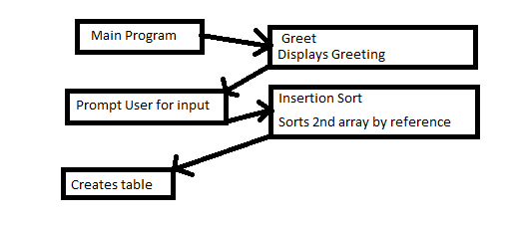
4. Limitations and Suggestions:

a. The array is at a constant size of 10, and its declared that way and cannot be changed by the user. Perhaps implement a way to incorperate a dynamitc size the user chooses.

b. Perhaps find a way to loop or cut down the amount of code needed to create the table needed to display the values in both arrays.

